Types of Frames
# Source: Chatgpt (GPT‑5 Mini) at [12/14/2025]
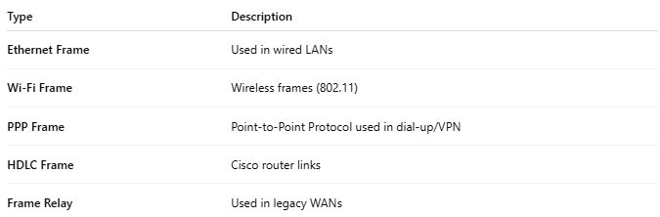
Type | Description
Ethernet Frame | Used in wired LANs
Wi-Fi Frame | Wireless frames (802.11)
PPP Frame | Point-to-Point Protocol used in dial-up/VPN
HDLC Frame | Cisco router links
Frame Relay | Used in legacy WANs

